RTL_EXERCISE_1 BOUND FLASHER
Author
Date | 2017/03/28
Version | 1.1

Contents
1. Interface 2
2. Functional implementation. 3
3. Internal implementation. 5
3.1. Overall. 5
3.2. State Machine 6
4. History 7

1. Interface

module_name
aaa
16
ddd
ccc
bbb
Figure 1: the figure of Bound Flasher System

Signal | Width | In/Out | Description
aaa | 1 | In
bbb | 1 | In
ccc | 1 | In
ddd | 16 | Out
Table 1: Description of signals in Bound Flasher

2. Functional implementation.
- Implement a 16-bits LEDs system
- System’s Operation base on three input signal
  - Reset
  - Clock
  - Flick
- The system specification
- Clock signal is provided for system inspire of function status. The function operate state’s transition at positive edge of the clock signal.
- Reset signal:
- LOW-ACTIVE Reset = 0: System is restarted to Initial State.
- HIGH-ACTIVE Reset = 1: System is started with initial state.
- Flick signal: special input for controlling state transfer.
- At the initial state, all lamps are OFF. If flick signal is ACTIVE, the flasher start operating:
- The lamps are turned ON gradually from LEDs [0] to LEDs [15].
- The LEDSs are turned OFF gradually from LEDs [15] to LEDs [5].
- The LEDSs are turned ON gradually from LEDs [5] to LEDs [10].
- The LEDSs are turned OFF gradually from LEDs [10] to LEDs [0].
- The LEDSs are turned ON gradually from LEDs [0] to LEDs [5].
- Finally, the LEDs s are turned OFF gradually from LEDSs [5] to LEDSs [0], return to initial state.
- Additional condition: At each kickback point (LEDs [5] and LEDs [0]), if flick signal is ACTIVE, the LEDs will go back and repeat that STATE. For simple, kickback point is considered only when the LEDs s are turned OFF gradually, except final state.

- Some insulations:
- When flick = 0 at kickback points
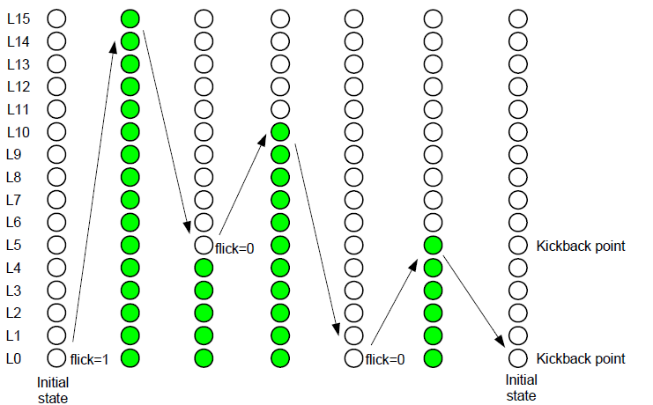

- When flick = 1 at kickback points (lamp[5])
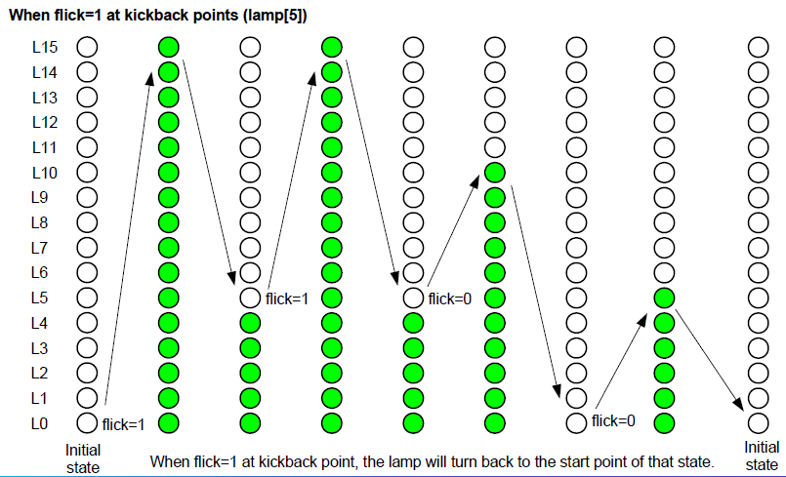

3. Internal implementation.

3.1. Overall.

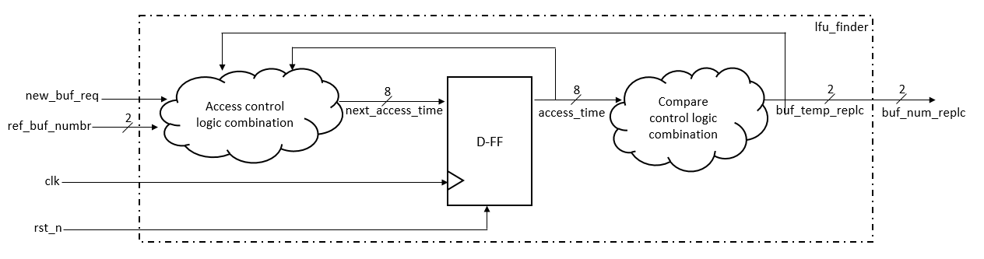

Figure 3.1: Block diagram of Bound Flasher
Table 3.1: Block diagram of Bound Flasher Description

3.2. State Machine

Figure 3.2: State Machine of Bound Flasher

Table 3.2: variable name of State machine

Table 3.3: state name of State machine

4. History

Date | Author | Modified part | Description
2017/03/28 |  | All | New creation

